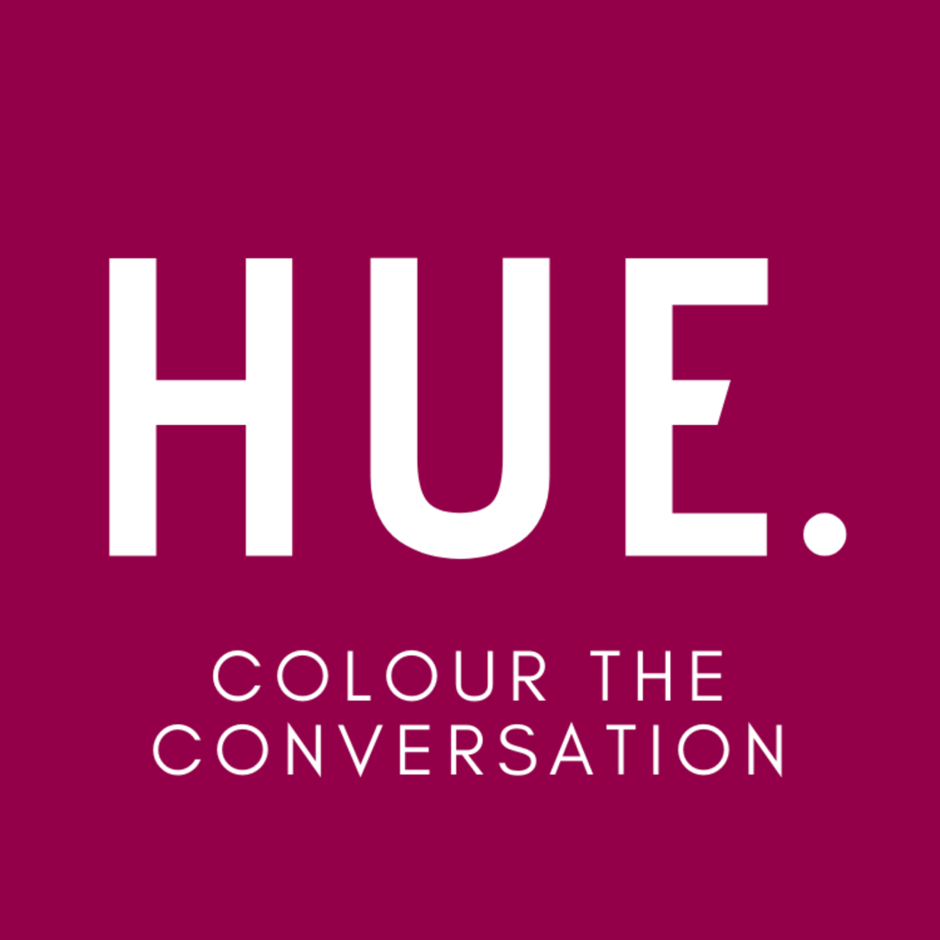

Hue: Colour the Conversation
Information Pack
About Hue
Hue Consulting was founded in 2020 by two women of colour - Elsa Tuet-Rosenberg and Sonia Sofat. We upskill and empower those seeking to learn about and challenge systems of oppression to create safer workplaces and social change.
Too often the conversations about challenging systems of oppression or allyship are tokenistic, one dimensional, and lack the ability to actually create change in our businesses, communities, organisations and movements.
Meanwhile people with lived experiences of these issues are often side-lined and tirelessly educating people in their interpersonal lives and in the workplace for free. That’s why Hue works with people with lived experience to develop content that provides practical skills needed to challenge systems of oppression.
Diversity and inclusion does not end at racial justice, which is why our approach is entirely intersectional.
Our work includes many areas such as age, gender, ability, sexual orientation, religious beliefs, language, education and socio-economic background.
We use a bottom up approach, where knowledge and power are accessed from within communities to inform organisations.
At Hue we acknowledge our privilege and that we live, work and play on stolen land. Everything that we do at Hue is grounded in deep respect for the history, culture, strength and resilience of the First Peoples of this continent.
This was and always will be Aboriginal land.

Our Clients
We deliver our training and professional development programs to a range of industries: from small to large businesses and corporations, to Government institutions, political parties, grassroots collectives, universities, schools and not for profit organisations. Our work is far reaching and can be adapted for a diverse range of audiences.
Our Team
The Hue team brings together over 35 years of experience in justice, equity, diversity and inclusion training, facilitation and consulting.
All our staff have lived experiences of racism which allows us to facilitate and create workplace solutions that truly have the empowerment of people of colour at their heart.
OUR FOUNDERS
Sonia is an Indian woman of colour who combines her passion for community organising, facilitation and anti-racism campaigning to create inclusive educational experiences.
She has over 10 years of experience working in the social justice sector, where she has led the design and implementation of activism and mobilisation strategies on human rights issues in Australia and around the world.
Elsa is a queer, Jewish and Chinese woman of colour. She is an educator, facilitator, activist and performer.
She has a background in Social Work and Psychology, and recently completed her honours thesis, an autoethnography on how multiracial people from multiple minority heritages engage with their identities.
Workshops
Our workshops use peer-to-peer learning frameworks to create learning programs that are accessible, engaging, interactive, and strengths-based.
They are delivered face-to-face or online, and run for 3 hours or 3.5 hours respectively, with 15-25 participants per session.
The sessions are hosted by people of colour who are trained facilitators and experts in their lived experiences.

Consulting
Hue supports businesses to create long lasting culture change solutions to create safer and more progressive workplaces for everyone.
We offer a range of consulting solutions for businesses including:
- Tailored anti oppression leadership training
- Workplace policy reviews
- Culture/intersectionality audits and recommendations
- Anti Racism Coaching
- Human resources and recruitment support
- Intersectional strategic planning facilitation
- Communications support
Why is antiracism training important for your workplace?
Racism in the workplace can be subtle and embedded in culture and tradition, which makes it difficult to call out and challenge, creating unsafe workplaces for many people of colour. Race based discrimination has very clear and adverse effects for individuals and businesses - these include, low staff commitment, trust and morale which can often lead to health issues. For organisations, this can result in increased turnover, low jobs satisfaction, reduced productivity, high recruitment costs, and high commitment of financial and staff resources to deal with grievances.
Racism and women of colour in the workplace
In a 2021 survey conducted by Women of Colour Australia and Murdoch University; majority of women said that they had faced challenges in the workplace (57.04%) related to their identity as a woman of colour.
In addition almost 60% of women who participated in the survey said they had experienced
discrimination in the workforce.
Racism in the workplace
Almost 33% of participants from a 2015-16 survey of 6000 people conducted by Western Sydney University survey said they had experienced racism in the workplace.
Recognising racism in Australia
According to the same Western Sydney University survey 8 out of 10 respondents recognised racism as a problem in Australia.
77% of survey respondents appreciate the need to challenge racism and for there to be anti racism initiatives.
How our training improves workplace culture and safety
Hue works to empower people and organisations with practical skills to challenge the root causes of systems of oppression and to improve and safety and support for people of colour in your workplace.
Build shared language & knowledge
We help participants to understand key terminology and their meaning so they can be better equipped in their understanding of racism and how to have conversations about racism in the workplace.
Build practical skills
Our workshops teach practical frameworks and conversation tools to help participants to identify racism in the workplace at a micro and macro level.
Expert facilitators with lived experience of racism
The workshops are hosted by people of colour who are trained facilitators and experts in their lived experiences, all who have lived experience of racism.
Participant Testimonials
"I really loved this workshop and think it should be essential for everyone (or every company!) to have this conversation. It was really comforting to speak to everyone about our shared experiences, learn new ways to describe how we're feeling - incredibly empowering."
"I like the practical elements and learning from others. It felt really safe to speak up and ask a question. It was really thought provoking and informing. I have greater confidence to have a conversation both at work and in social circles regarding racism. It is far less confronting. It has really opened up how I could address this in the workplace."
"Thought provoking. The workshop brought some new ideas and issues to light, and gave me some tools to better articulate myself when discussing and thinking about what racism is, what its effects are and what we can do to fight it."
"This session has helped me reflect on my organisation's culture, my role within it, and how that affects people with lived experiences that differ to my own - particularly people of colour. "

101: Understanding Race & Racism
This workshop is an introductory workshop that develops literacy, empathy, understanding of race related issues and identities, and improve safety and support for people of colour in your organisation, movement or place of work. The program develops shared language and understanding across your organisation about what racism is and what it looks like in practice, and is a crucial first step to meaningful antiracism work. It is appropriate for a range of knowledge levels and experiences, and creates a safe environment for real conversations about race and racism.
LEARNING OUTCOMES
- To understand and use appropriate and nuanced race related vocabulary.
- To contextualise racism within a structural framework.
- To develop understanding of the impacts of racism on people of colour and First Nations people.
- To develop critical thinking and understanding of context of racist stereotypes and tropes.
- To analyse the ways privilege and disadvantage exist within communities of colour.
- To generate and feel equipped to take actions that improve safety for people of colour and tackle racial injustice.
"Accessible but deeply engaging discussion. You held the room with grace and humility and it felt like a comfortable space to take guesses. I haven't had such a frank discussion around race in a long time and didn't want it to end!"

Allyship In Your Workplace
As a follow up to our 101: Understanding Race & Racism training, this workshop converts your newly developed understanding of race and racism into practical skills that can be applied to your specific workplace setting or context. This workshop uses a combination of group work, role play, and personal reflection to develop capacity for allyship, accountability and empowered change.
We also have a version of this workshop that approaches allyship through a more intersectional lens, for organisations that have been working on inclusivity beyond racial justice. The training is most affective when there is participation from all levels of your organisation.
LEARNING OUTCOMES
- To reflect on privilege and how it can be leveraged for action and change.
- To develop understanding of allyship and what this looks like day to day.
- To analyse and explore common pitfalls of inclusion and allyship.
- To create a culture of personal and professional accountability around racism in your organisation.
- To explore what empowerment for people of colour looks like in your organisational and industry setting.
- To equip participants to respond to racism and discrimination within the organisation.

"This session was really helpful as a business leader to help build a set of actions that we can take in order to progress on our anti-racism journey. Grateful that the way you structured the session allowed for that documentation!"
- Future Super

POC Power & Resilience
(People Of Colour Only)
This workshop creates a safe space for people of colour at your organisation to share, reflect, connect and learn without the impact of the white gaze. Together, we explore how our experiences are shaped by racism and whiteness, internalised racism, community solidarity, collective liberation, and develop skills and practices for individual and community care and joy. The session also explores strategies for coping and wellbeing under oppressive and racist systems.
This workshop is for a minimum 10 and maximum of 20 participants per session.
LEARNING OUTCOMES
- To build solidarity among people of colour on your team.
- To the ways we may internalise whiteness and racism.
- To explore the ways we as people of colour may internalise racism and whiteness.
- To reflect on our relative positionality and privilege that we hold within communities of colour.
- To reflect on individuals wellbeing and build strategies to improve resilience and wellbeing.
- To explore the different ways people of colour can, and do enact their power to create change.
- To create a safe space for people of colour to reflect on their experiences, skills and strategies for responding to racism.
"The session actually made me realise many of the the things I have been holding inside of myself growing up as an Asian girl in Australia"
-Workshop participant

Deconstructing whiteness
As a follow up to our 101: Understanding Race & Racism workshop, this program creates a safe and reflective space for participants to critique and examine dominant whiteness culture within themselves and society more broadly. The session explores a range of ways that whiteness can pervade our psyches, sense of self, and attempts at allyship. This goes beyond a systemic unpacking of racism and racial justice, and is best for participants who are ready to challenge themselves.
LEARNING OUTCOMES
- To understand, articulate and critique how whiteness shapes our societies, values and identities.
- To develop understanding of concepts such as: white fragility, white saviour complex, white guilt & tone policing.
- To explore the interconnected nature of systems of oppression and their connection to whiteness and colonialism.
- To develop understandings of the impacts of whiteness on people of colour.
- To develop critical analysis skills and ability to recognise whiteness in a range of forms.
- To create space for reflection on individuals' relationship to whiteness.
- To critique the ways whiteness informs our workplace structures.

"I liked how uncomfortable and confronting it was which in itself is part of the challenge we have to tackle and the system we benefit from and uphold! It was like learning and experiencing the content all in one."
-Minus 18

Community organising
This workshop is a crash course in community organising, designed to equip participants with the skills to build and empower their own communities to challenge systems of oppression and work towards justice on the issues that impact them. This program is focused on drawing on lived experience and mobilising and strengthening our own communities. The training draws on bottom up approaches that recognise the skills, power and self-determination of our own communities, and the leaders among us.
This program runs for two hours face to face, and uses a mix of group work and facilitation throughout the session.
LEARNING OUTCOMES
- Develop critical skills for strategic decision making, and how to pick strong and impactful tactics and actions
- Learn to create long and short-term strategic goals
- Understand the importance of community and leadership mapping and develop the ability to create your own
- Develop skills and practices for meaningful relationship & community building through one-on-one conversations

Navigating Whiteness In The Workplace
(People Of Colour Only)
This session explores how whiteness operates in not-for-profit organisations and how it influences ways of working, thinking and engaging with community and supporters. We discuss red and green flags to look out for as a person of colour when applying for jobs or volunteer positions, how to learn more about organisations track record with anti racism, inclusion, justice and how to set boundaries, manage burn out and prioritise your well being while being in these spaces.
This program runs for two hours, and uses a mix of group work and facilitation throughout the session.
LEARNING OUTCOMES
- Explore how you can decide as a POC what paid and unpaid roles to apply for
- What to look at when making a decision about potentially working with an organisation/campaign and red flags to watch out for
- How to learn about an organisation's track record with POC and their activism work (especially beyond what's publicly available on their official channels)
- How to protect yourself from burning out as a POC in a white NGO space

Inclusive Feminist Spaces
This workshop is designed for women centred organisations looking to reflect on their positionality, relationships and inclusion of multiply marginalised people in their movements. Typically, women's spaces prioritise or can be dominated by cisgender, white women, while the needs of transgender folks and people of colour are ignored. This workshop looks at safer practices & language, meaningful inclusion, and the relationships between our collective fights for justice as part of a mission to uplift all people experiencing gender based oppression. A 101 workshop from Hue or Nevo Zisin is a pre-requisite to this program.
This session is co-facilitated by facilitators who are women, transgender, gender diverse and/or people of colour and has a co-facilitation fee.
LEARNING OUTCOMES
- To understand, articulate and critique how people of colour and transgender people may be excluded from women's spaces
- To develop inclusive vocabulary and understanding of language that is safe or that may inadvertently cause harm.
- To explore the interconnected nature of systems of oppression and our collective fight for justice under patriarchy, white supremacy and cis-normativity.
- To understand the intersectional nature of womanhood, transness, femininity and race.
- To develop tangible actions and considerations to make our feminism and feminist spaces more inclusive.

Created and delivered in collaboration with Nevo Zisin: Jewish, queer & non-binary author, activist, performer & educator.

Board & Senior Leadership Antiracism Series
This workshop series is delivered across three 2 hour sessions, designed specifically for board members and senior leadership. This series offers an amended version of our three workshop programs: 101: Understanding Race & Racism, Deconstructing Whiteness & Allyship in Your Workplace. The program is condensed to address the time limitations that many boards and senior management teams have, and addresses many of the issues that directly impacts senior leadership, including: Justice, Equity, Diversity & Inclusion implementation, common leadership challenges in justice work, structural and cultural components of organisational change, and risk appetite in justice work.
LEARNING OUTCOMES
- To contextualise racism within a structural framework.
- To develop understanding of the impacts of racism on people of colour and First Nations people.
- To understand, articulate and critique how whiteness shapes our societies, values and identities.
- To critique the ways whiteness informs our workplace structures.
- Reflect on challenges in organisational leadership for meaningful justice, equity, diversity and inclusion work.
- To analyse and explore common pitfalls of inclusion and allyship.
- To create a culture of personal and professional accountability around racism in your organisation.
- To understand the personal, structural and cultural elements of organisational change.

Accessibility
ONLINE ACCESS:
A computer device with microphone and camera is required to access all components of the workshop. Slides are accessible via google slides. Text is written with bright colour contrast in upper and lower case, and large clear font. Image descriptions via alt text are included for any images on the slides.
We are currently using Zoom auto-captions for the main sessions of our workshops, which is not available in break out rooms.
There are two 5-minute breaks and one 10-minute break. Participants are encouraged to eat, drink or move around if they need to and are welcome to turn their video off for these times if this is more comfortable.
Participants are also asked if they have any additional accessibility requirements at the start of the session for the facilitator to consider.
FACE TO FACE:
It is the booking organisation’s responsibility to ensure their venue is accessible to their staff and participants. This may include but is not limited to: a wheelchair accessible venue, disabled & gender neutral bathrooms, appropriate & comfortable seating inclusive for all sizes and wheelchairs, spacious organisation of furniture, accessible via wheelchair accessible public transport.
INTERPRETERS:
We use interpreters for our sessions when required by participants. If your organisation has booked our workshops, it is the responsibility of the organisation to book an interpreter and we will liaise with them and provide necessary resources prior to the session.
We are always open to and appreciative of feedback on how to make our work more accessible

Reviews
Such a great session. We delved into deep and emotional topics and the facilitation was excellent. Our team is still talking about it! Thank you for this powerful and brilliant session.
-Oxfam
I enjoyed all of it!! Presenter was so engaging and knowledgeable. Discussions were fantastic: hearing people’s lived experiences and reflecting on my own behaviour. Topics were discussed with truth, sensitivity and passion.
-Future Super
Very understanding and digestible way to talk about race and racism. The session gave me a new way to look at things. Despite having experiences with racism myself, there were a lot of things that were new to me and that I have learned from.
-Think Impact
Incredibly informative. Didn't avoid tough conversations/sensitive topics. Facilitator was amazing, incredibly charismatic, and spoke on all topics with complexity and nuance.
-Monash University
I love how interactive and reflective it was. This workshop helped me to question how whiteness works on so many levels - personal, interpersonal, institutional, systemic. Such a valuable experience.
-Thorne Harbour Health

Accessibility
Online Access:

A computer device with microphone and camera is required to access all components of the workshop.
Slides are accessible via google slides. Text is written with bright colour contrast in upper and lower case, and large clear font. Image descriptions via alt text are included for any images on the slides.

We are still trialling online captioning services.

There are two 5-minute breaks and one 10-minute break. Participants are encouraged to eat, drink or move around if they need to and are welcome to turn their video off for these times if this is more comfortable.

Participants are also asked if they have any additional accessibility requirements at the start of the session for the facilitator to consider.

Face to face:

When organisations book our workshops, they provide the venue for the workshop. It is the organisation’s responsibility to ensure their venue is accessible to their staff and participants. This may include but is not limited to: a wheelchair accessible venue, disabled & gender neutral bathrooms, appropriate & comfortable seating inclusive for all sizes and wheelchairs, spacious organisation of furniture, accessible via wheelchair accessible public transport.

For attendees at a community session hosted by Hue, we will ensure that these access requirements are met by our venues.
Auslan interpreters:

We use Auslan interpreters for our sessions when required by participants. If your organisation has booked our workshops, it is the responsibility of the organisation to book an interpreter and we will liaise with them and provide necessary resources prior to the session. For attendees at a community session hosted by Hue, please let us know you require an interpreter, and we will organise one for the session.

Financial Access:

We aim to make our workshops financially accessible to a range of organisations and individuals whilst honouring the labour of speaking to lived experience. This is why the prices of our workshops are scaled for differently sized and structured organisations and community groups, and our community workshops always have unwaged options with no one turned away due to lack of funds.

We are always open to and appreciative of feedback on how to make our work more accessible.
FAQs
Why is there a limit on the number of people who can attend a workshop?
Our workshops are specifically designed to provide a safe environment for people to learn and unpack their understanding of racism and systemic oppression. The safety of the participants and our facilitators is of the utmost important to us. Part of ensuring that these discussions are facilitated safely, is limiting the number of participants so that the sessions are manageable. For this reason, the workshop's are capped at 25-30.
Is there a shortened version of your training available?
Our training is timed to cover the learning objectives in a way that allows for deep and meaningful learning. While we can amend our anti-racism training to a shortened version, to explore some topics around racism and racial justice, it does not achieve the deep comprehensive learning or scope of our 3.5 hour sessions.
Is your training First Nations solidarity training?
This training is not First Nations solidarity training, and we encourage organisations to do First Nations specific training before or alongside our training programs. Our workshops have been developed with advice and paid consultation with First Nations people, however we recognise that our communities are not a monolith, and welcome feedback on our content. Whilst we are not a First Nations specific training, we recognise that issues of racial justice disproportionately impact First Nations people, and this inherently informs our discussions in our workshops.

Should First Nations people and people of colour be attending this training?
We believe that people of colour benefit from developing our understanding and vocabulary in describing our experiences, and that we are all at different stages of our understanding of these experiences. We also recognise that there is vast diversity among people of colour, and that we also have responsibility to reflect on our positionality within the racist systems we are apart of. However, we also recognise the labour and energy that goes into unpacking these experiences, and therefore encourage that these sessions are optional for First Nations staff and volunteers.
Is there any pre-reading to do before the sessions?
While there are many resources that we encourage you to explore, accessible via our resources page, pre-reading is not necessary for the workshops.
Is antisemitism or Jewish experience spoken to in the workshops?
As one of our co-founders and content creators is a Jewish person of colour, and as antisemitism is a form of racism experienced by POC and white-passing people alike, some topics discussed in our workshops also relate to aspects of Jewish experience. However, similarly to East Asian identities, proximity to whiteness significantly impacts the scale and nature of racism experienced by Jewish people, and our workshops aim to centre those most impacted, particularly First Nations peoples, and is thus not a focus of our training. An excellent (albeit US centric) resource that explores antisemitism and its nuances in contrast to other forms of racism can be found here.
Do you do unconscious bias training?
We do not run unconscious bias training. We believe the best way for people to build their understanding of structural racism and oppression is to understand the issues and structures that create these oppressive conditions. Our workshops are designed to support participants to unpack their understanding of issues, deepen their self awareness and their understanding of racism and oppression. Our style of facilitation and workshop development help individuals develop tangible ways they can implement anti oppressive approaches in their personal lives and workplaces.

